GUVI task 16

1. Create a code commit repository. For that go to code commit in aws console, give it a name and create it

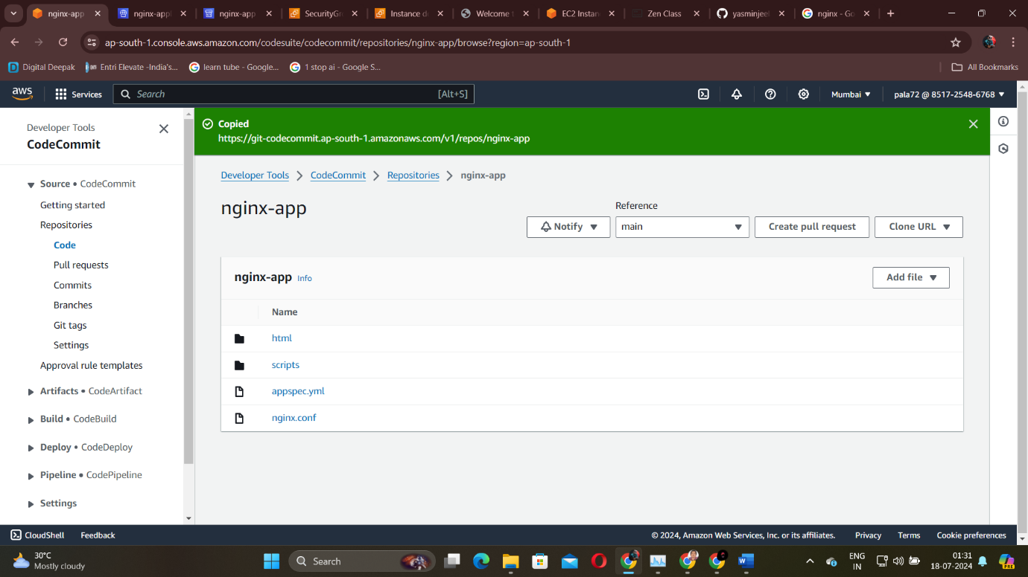

After creating clone the repository either https or ssh

1. Before cloning the repository open your ec2 instance check for updates then install awscli, aws configure , check whether git is there(optional), then give your github username, email and then give git clone.
2. After doing all those things open the nginx-app directory in instance. Then open another directory inside it and name it as html. In that add a file named index.html with the required html code.
3. Now come out of it and give the nginx.conf file with details for configuration.
4. Next create appspec.yml with the application details.
5. Next create a directory named scripts inside nginx-app and create a file called start_server.sh

[ as there are so big lines in the terminal while executing these commands im not able to post screenshot of each of these commands step by step]

1. Next do the push to code commit by giving the commands git add, git commit, git push
2. Next setup code deploy. For that go to code deploy console create a application with a name and choose ec2 on premises as compute platform.

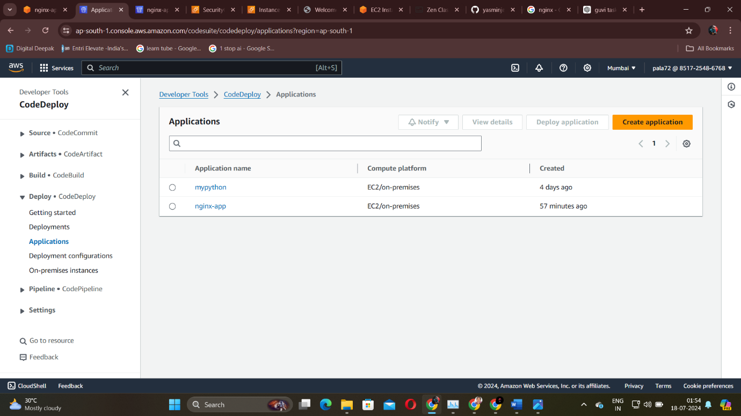

1. Next create a code deployment group.Name your deployment group (e.g., nginx-deployment-group).Select a service role with CodeDeploy permissions.Choose your EC2 instance by selecting the tag or manually choosing the instance.Set the deployment type to “In-place”.Configure any other settings as needed and click “Create deployment group”.
2. Next code pipeline. Go to aws code pipeline console. Create a pipeline and name it. • Select CodeCommit as the source provider.

Choose your repository (nginx-app) and branch (e.g., master).

Click “Next”.

1. Click “Skip build stage” since this simple deployment doesn’t require a build step.Click “Next”.Select CodeDeploy as the deploy provider.Choose the application and deployment group you created earlier.Click “Next”.Review your settings and click “Create pipeline”.
2. Open http port 80 in security group. Open security settings of your instance and open launch wizard. In that click edit inbound rules and add http – 80 port.

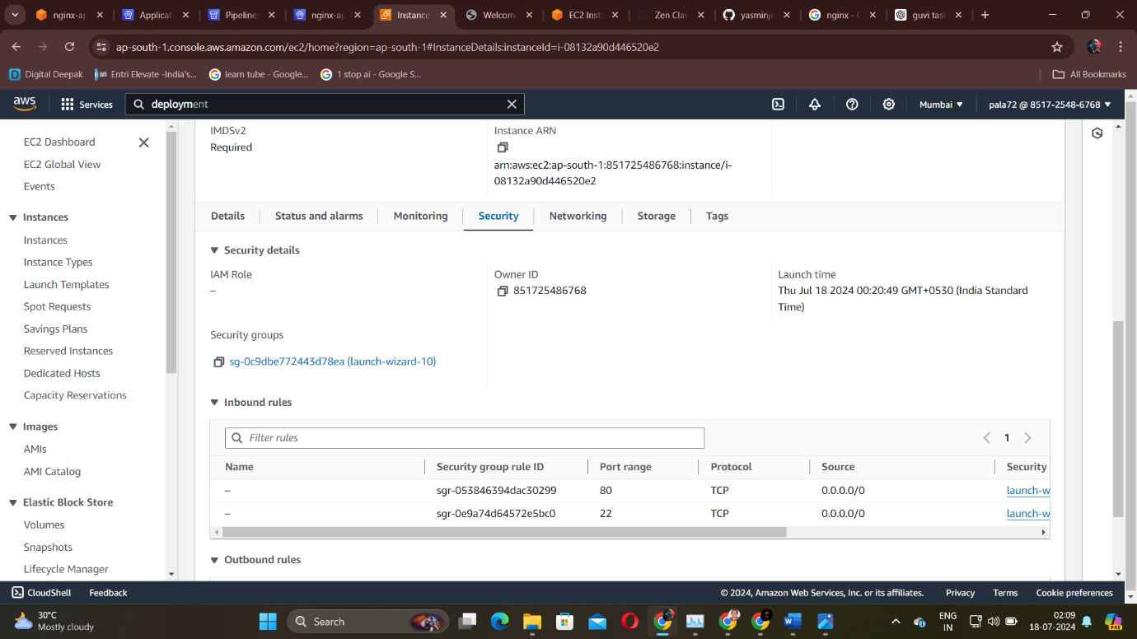

1. Monitor your pipeline and ensure the pipeline stages complete successfully.
2. Now go to your ec2 instance, check if nginx is there if not install nginx
3. Next check status of nginx, if it shows running only then we can believe it is running.

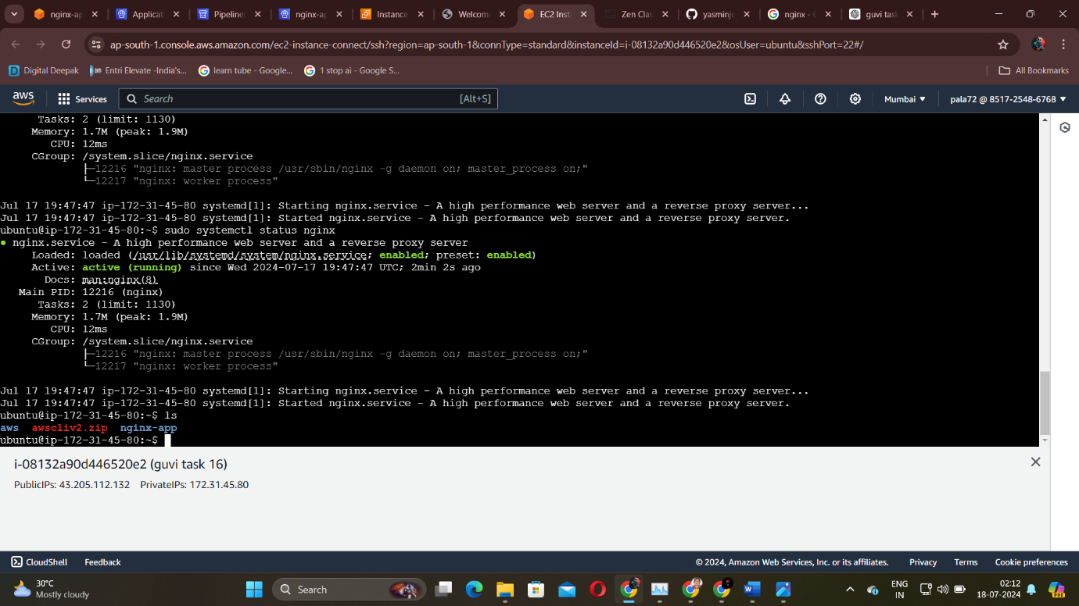

1. Now open your public ec2 instance address in a new browser or new tab and there you should see nginx welcome page or custom page.

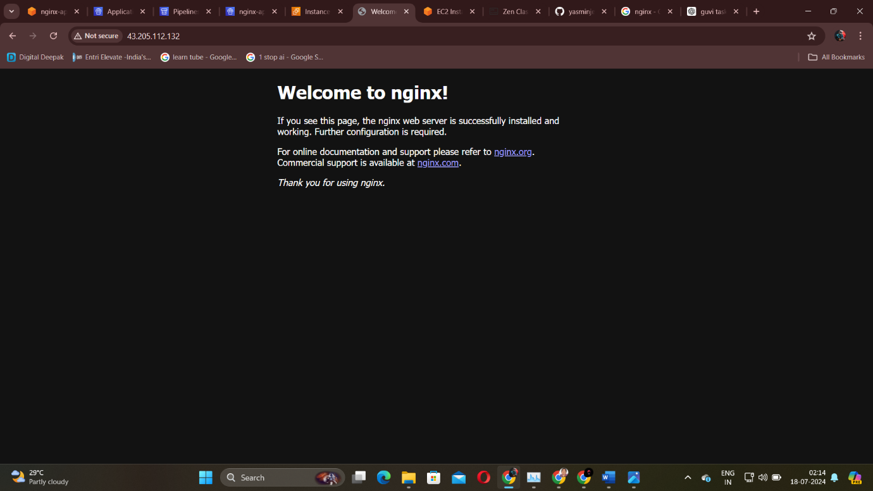

-----X-----